A
Project Report On

ACADEMIA

Submitted in partial fulfillment for award of the degree of

Bachelor of Technology In
Computer Science and Engineering
By

Mohit Singh Adhikari

Harshita Bisht

Mayank Singh Mewari

Adarsh Bisht
Under the Guidance of
Mr. Rahul Singh ASSISTANTPROFESSOR
DEPARTMENT OF COMPUTER SCIENCE AND ENGINEERING

DEPARTMENT OF COMPUTER SCIENCE & ENGINEERING GRAPHIC ERA HILL UNIVERSITY, BHIMTAL CAMPUS SATTAL ROAD, P.O. BHOWALI,

DISTRICT- NAINITAL-263132 2024-2025

STUDENT’S DECLARATION


We, Mohit Adhikari, Harshita Bisht, Mayank Singh Mewari and Adarsh Bisht declare the work, which is being presented in the project, entitled ‘ACADEMIA’ in partial fulfillment of the requirement for the award of the degree Bachelor of Technology (B.Tech.) in the session 2024-2025, is an authentic record of my work carried out under the supervision of Mr. Rahul Singh.
The matter embodied in this project has not been submitted by me for the award of any other degree.

Date: Mohit Adhikari

Harshita Bisht

Mayank Mewari

Adarsh Bisht


CERTIFICATE

The project report entitled “ACADEMIA” being submitted by Mohit Adhikari S/o Mr. Bahadur Singh Adhikari, 2161236, Harshita Bisht D/o Mr. Lakhan Singh Bisht, 2161172, Mayank Mewari S/o Mr. Ganesh Singh Mewari, 2161230, Adarsh Bisht S/o Mr. Hemant Kumar Bisht, 2161061, of B.Tech.(CSE)to Graphic Era Hill University Bhimtal Campus for the award of bonafide work carried out by them. She has worked under my guidance and supervision and fulfilled the requirement for the submission of a report.

Mr. Shashi Kumar Sharma Mr. Ayush Kapri Dr. Ankur Singh Bisht

(Project Guide) (Project Coordinators) (Head, CSE)

ACKNOWLEDGEMENT


We take immense pleasure in thanking the Honorable Director ‘Prof. (Col.) Anil Nair (Retd.)’, GEHU Bhimtal Campus to permit me and carry out this project work with his excellent and optimistic supervision. This has all been possible due to his novel inspiration, able guidance, and useful suggestions that helped me to develop as a creative researcher and complete the research work, in time.
Words are inadequate in offering my thanks to GOD for providing me with everything that we need. We again want to extend thanks to our president ‘Prof. (Dr.) Kamal Ghanshala’ for providing us with all infrastructure and facilities to work in need without which this work could not be possible.
Many thanks to ‘Dr. Ankur Singh Bisht’ (Head, Department of Computer Science and Engineering, GEHUBhimtal Campus), our project co-ordinators ‘Mr. Ayush Kapri’ (Assistant Professor, Department of Computer Science and Engineering, GEHUBhimtal Campus), our project guide Mr. Shashi Kumar Sharma, Assistant Professor, CSE Dept. and other faculties for their insightful comments, constructive suggestions, valuable advice, and time in reviewing this thesis. Finally, yet importantly, we would like to express my heartiest thanks to my beloved parents, for their moral support, affection, and blessings. We would also like to pay my sincere thanks to all my friends and well-wishers for their help and wishes for the successful completion

of this research.
Mohit Adhikari (2161236)
Harshita Bisht(2161172)
Mayank Mewari (2161230)
Adarsh Bisht (2161061)

ABSTRACT

In today’s fast-paced academic environment, students often face the challenge of juggling multiple platforms for their educational and recreational needs. To solve this problem, this project presents Academia, a centralized, web-based system that combines academic support, intelligent course recommendations, test and proctoring features, and real-time entertainment booking—all in one unified platform.

The system is divided into two core modules: Academics and Entertainment.
The Academics Module helps students manage their learning journey efficiently. It offers features such as study material access, goal-based course recommendations, opportunity alerts, academic progress tracking, test-taking with AI-powered proctoring, and more. At the heart of this module is an Intelligent Course Recommendation System that uses machine learning algorithms—including content-based and collaborative filtering, NLP, clustering, and classification techniques—to recommend the most relevant online courses based on the student’s stream, goals, and interests. The system also adapts over time using feedback and behavior analysis.

The Entertainment Module focuses on ease and speed in discovering and booking movie or event tickets. To prevent issues like double booking or seat conflicts, it uses real-time seat management with WebSocket-based concurrency control, ensuring a smooth and reliable user experience.
The entire system is built using modern technologies such as React.js for the frontend, Node.js and Express for the backend, and MongoDB and PostgreSQL for data handling. It is deployed on the cloud using Docker containers and managed with Kubernetes, which ensures scalability, high availability, and smooth performance under load.

Academia aims to become a one-stop solution for students by combining the power of intelligent recommendation, efficient resource access, smart test handling, and interactive entertainment—all in a clean, user-friendly interface. Academia provides a modern, easy-to-use solution for students' everyday needs—whether academic or recreational—helping them stay organized, focused, and balanced.

TABLE OF CONTENTS

Declaration… 2
Certificate… 5
Acknowledgement… 8

Abstract… 9
Table of Contents… 10
List of Abbreviations… 11
List of Figures… 12
GIT details………………………………………………………………………13
CHAPTER 1
INTRODUCTION 14
1.1
Prologue… 14
  - Background and Motivations… 15
  - Problem Statement… 15
  - Objectives and Research Methodology…………………………………… 16
CHAPTER 2 PHASES OF SOFTWARE DEVELOPMENT CYCLE
  - Hardware Requirements… 25
  - Software Requirements… 25

CHAPTER 3 CODING OF
FUNCTIONS 27
CHAPTER 4
SNAPSHOT 38

CHAPTER 5 TESTING STRATEGISES 43
CHAPTER 6 LIMITATIONS 45
CHAPTER 7
ENHANCEMENTS 47
CHAPTER 8
CONCLUSION 49
REFERENCES 50

LIST OF ABBREVIATIONS
AI :Artificial Intelligence
API: Application Programming Interface
ORM: Object Relational Mapping
NPM: Node Package Manager
NLP: Natural Language Processing
ML: Machine Learning
REST: Representational State Transfer
K8s: Kubernetes


LIST OF FIGURES

Figure | Title | Page Number
Fig 1.1 | Workflow using Blockchain
Fig 1.2 | QR Sample
Fig 1.3 | System Architecture
Fig 2.1 | Structure of a Blockchain
Fig 4.1 | Home Page
Fig 4.2 | Add a product section in Manafacturer module
Fig 4.3 | Sell product to a Seller
Fig 4.4 | Product for Sales
Fig 4.5 | Product Verification
Fig 4.6 | Contract deployed in Ganache
Fig 4.7 | Blockchain transaction in Ganache

CHAPTER 1

INTRODUCTION

Prologue

In today’s digital age, students are constantly surrounded by online tools for learning, skill development, and entertainment. From watching educational videos to attending online classes and appearing in remote tests, the shift towards digital platforms has become a normal part of academic life. At the same time, students also seek entertainment to relax and unwind—through movies, events, or social content. However, despite the availability of multiple online platforms, there is no unified system that helps students balance both aspects of their daily routine—academic and recreational needs—in one place.
This project, titled Academia, was developed to fill that gap. Academia is a centralized web-based platform that brings together two essential parts of a student’s life: academics and entertainment. The system has been carefully designed to support students in their academic journey while also offering features that support recreation and relaxation.

The Academics Module of Academia focuses on enhancing learning, exploration, and preparation. It includes a smart Course Recommendation System that uses machine learning algorithms such as content-based filtering, collaborative filtering, clustering, and natural language processing (NLP). This helps in suggesting personalized online courses based on the user’s academic background, goals, or even uploaded resumes. Additionally, the platform supports online test conduction and proctoring, allowing institutions or educators to schedule tests, while students can appear for them from anywhere with secure monitoring. These tests are integrated with AI-based proctoring features that ensure fairness and minimize malpractice by tracking student behavior during the test.

The Entertainment Module is built to offer an effortless experience for discovering and booking movie or event tickets. It features a real-time seat selection and booking system that uses WebSockets and concurrency control to prevent double bookings. This is especially important during high-demand times, like first-day-first-show movie releases, ensuring the system handles multiple users efficiently and fairly.
Academia has been implemented using ReactJS for the frontend, Node.js/Express for the backend, and MongoDB/PostgreSQL for data storage, depending on the module. The deployment uses Docker containers and Kubernetes for orchestration, ensuring that the system remains scalable, reliable, and cloud-ready. Real-time operations, intelligent recommendations, and secure test handling are all supported using modern technologies like WebSockets, NLP, clustering, and AI-based classification models.

The overall purpose of Academia is to make student life more productive and enjoyable by reducing the need to switch between different platforms. Whether a student wants to prepare for a new skill, take a test, or simply book a movie ticket with friends, Academia makes it all possible from a single portal.
In the long run, this platform can be expanded to include additional features such as doubt forums, course reviews, payment integration, event hosting, and much more. Academia, therefore, serves as a foundation for a smart, student-centered digital ecosystem that continues to grow and evolve with user needs.

Background and Motivation


In the current digital era, students are increasingly reliant on online tools and platforms to support their academic journeys and personal lives. With the growing demand for personalized learning, real-time resources, and recreational outlets, institutions are exploring integrated systems that can streamline these varied aspects into a single platform. However, most existing platforms focus either solely on academics (like Learning Management Systems or exam portals) or on external entertainment (like movie ticketing apps), without offering a holistic, student-focused solution that addresses both.

Academia was conceptualized in response to this gap. It is designed to bridge the divide between academic support and personal engagement, creating a centralized platform that not only aids students in discovering suitable learning resources but also enhances their campus life through integrated entertainment services. The idea emerged from observing the fragmented nature of student tools—students often juggle between multiple applications for academic tracking, resume building, course recommendations, event updates, and booking seats for campus activities or movies. This fragmentation leads to inefficiency, missed opportunities, and a lack of personalization.

The academic landscape itself is evolving rapidly. With the proliferation of Massive Open Online Courses (MOOCs), students are now exposed to thousands of learning options across different domains. However, identifying which course best fits a student's goals, academic background, and interests can be overwhelming. Often, students enroll in trending or peer-recommended courses without truly understanding if they are aligned with their career paths. There is a strong need for a smart recommendation system that not only understands what a student wants but also suggests what they need based on their past academic behavior, future aspirations, and market trends.
Moreover, exams and evaluations are increasingly shifting to online platforms, making test management and proctoring essential features in any academic tool. Academia integrates a secure and accessible test platform with support for basic webcam-based proctoring, helping institutions conduct fair assessments while saving logistical efforts and costs.

On the other side, the entertainment and social side of student life is equally important. Engaging in cultural events, movie screenings, or recreational activities helps reduce stress and promotes better mental well-being. With many colleges organizing on-campus movie nights, festivals, or workshops, a reliable real-time booking system becomes essential to handle registrations, avoid overbooking, and offer a seamless user experience. Most booking platforms are external and costly, and they don't integrate with academic tools. Academia brings this into one ecosystem.
From a technological perspective, the project is also motivated by the opportunity to apply modern web development techniques, concurrency control using WebSockets, recommendation algorithms, and deployment strategies (like Docker and Kubernetes). These not only make the project robust and scalable but also prepare students for industry-relevant tools and practices.

In summary, the motivation behind this project is to enhance the student experience by offering an all-in-one solution for managing academics, discovering opportunities, appearing for tests, and enjoying campus life events. Academia is not just another student portal; it’s a student-centered digital assistant, designed to grow with the user and support them throughout their academic journey.

Problem Statement

Students today face a variety of academic and extracurricular challenges that stem from the lack of a unified digital platform. Despite the availability of many online tools and services, these resources are often scattered across different websites and applications, making it inconvenient for students to manage their academic life, discover new learning opportunities, book recreational events, or even appear for tests.
Academically, students struggle to find the right online courses that match their interests, stream, and career goals. Most platforms provide generic recommendations that don’t take into account individual academic history or aspirations. Additionally, resume creation, opportunity tracking (internships, certifications), and test-taking facilities are often not personalized or integrated, resulting in disorganized workflows and missed prospects. Students must manually search for relevant content, prepare their profiles from scratch, and keep track of deadlines, which is time-consuming and inefficient.
In terms of entertainment and event participation, students face difficulties booking seats for campus movie screenings, events, or shows due to outdated systems or manual booking processes. Issues such as double-booking, overbooking, or lack of real-time updates often create frustration. Moreover, no academic portal supports real-time event booking using modern techniques like WebSockets or seat-locking concurrency mechanisms.
Further, test management and proctoring have become essential in the wake of digital examinations. Many institutions rely on third-party services that are either costly or lack integration with student profiles. This leads to inconsistencies in assessment management and increases the chances of academic dishonesty or mismanagement.
In short, there is no centralized, intelligent platform that:
- Recommends academic courses based on a student’s stream, performance, and goals.
- Helps students manage their profiles and access learning opportunities in a personalized way.
- Provides a real-time and efficient system for event or movie ticket booking.
- Offers a secure and integrated platform for online tests and basic proctoring.
- Combines academics and recreation under one cohesive interface.
Academia aims to solve these problems by delivering a unified web-based solution that blends intelligent academic tools with real-time event booking features, providing students with a seamless, smart, and student-first digital experience.

Objective


The primary objective of the project Academia is to develop a unified, student-centric web platform that combines academic tools and entertainment services in one seamless interface. It aims to simplify and enrich the student experience by intelligently recommending learning content, enabling real-time ticket booking, and supporting assessments. The following are the specific objectives:

Develop a Hybrid Course Recommendation System

Use machine learning techniques such as content-based filtering, collaborative filtering, and clustering to provide personalized course suggestions.

Analyze user input (e.g., interests, stream, goals) using NLP to fine-tune recommendations.

Enable Smart Academic Management

Allow students to input and update their academic details.

Generate resumes automatically based on their profile and achievements.

Send personalized alerts for internships, certifications, and learning opportunities.

Implement a Real-Time Event and Movie Ticket Booking System

Allow users to browse upcoming events and movies.

Use WebSockets and concurrency control to manage real-time seat selection and avoid overbooking.

Integrate Online Test and Proctoring System

Provide a basic yet secure interface for students to take scheduled tests.

Implement webcam-based test proctoring or monitoring features using browser APIs or snapshots.

Support file uploads and time-based assessments.

Ensure Scalable and User-Friendly Design

Use a modern tech stack including React (frontend), Node.js (backend), and MongoDB/PostgreSQL (database).

Ensure responsive design, smooth user flow, and modular code architecture for future scalability.

Maintain Data Security and Performance

Use secure authentication mechanisms.

Ensure smooth performance under concurrent usage, especially during bookings or tests.

Employ containerization (e.g., Docker) and deployment tools (e.g., Vercel, Render) for scalability.

Research Methodology

To achieve the above objectives, the project follows a structured and iterative approach inspired by Agile development practices. The development is guided by the following methodology:

Requirement Gathering and Analysis

Survey of student pain points through informal feedback.

Analysis of existing portals like Coursera, BookMyShow, and college ERP systems to identify gaps.

Technology Selection and Stack Finalization

Chosen technologies:

Frontend: React JS, Tailwind CSS, Redux


Backend: Node.js with Express

Database: MongoDB for course data, PostgreSQL with Prisma for event bookings

WebSockets: Socket.io for real-time seat locking

Testing: Postman, Jest, and browser-based test cases

System Design

Design modular architecture for Academics and Entertainment modules.

Define APIs and database schema for each functionality.

Use JWT-based authentication for secure access control.

Model Training and Integration

Train ML models for course recommendation using dummy datasets (based on user stream, goals, etc.).

Integrate Python-based AI services with the backend using RESTful APIs.

UI/UX Design and Prototyping

Create wireframes and responsive interfaces using Figma and Bootstrap/Tailwind.

Incorporate feedback from peers during initial testing.

Implementation and Testing

Use Git for version control and collaborative coding.

Conduct unit, integration, and end-to-end testing.

Simulate booking concurrency scenarios and online test workflows.

Deployment and Final Review

Host frontend and backend on Vercel and Render respectively.

Final review of system performance, usability, and functionality.

Document system for academic submission.

Scope of the Project

The Academia platform is envisioned as a centralized and integrated solution to address diverse student needs by combining academic tools and entertainment services in one cohesive web-based system. The project’s scope encompasses the following key aspects:

Intelligent Course Recommendation:
The system leverages hybrid machine learning algorithms, including content-based and collaborative filtering, to offer personalized course suggestions tailored to each student’s academic background, interests, and career goals. This helps students navigate the vast array of online courses efficiently, saving time and improving decision-making.

Online Test and Proctoring:
Academia incorporates a secure online testing environment with proctoring features that monitor students during exams, ensuring academic integrity. This module supports test creation, scheduling, real-time monitoring, and automated flagging of suspicious activities, making it suitable for both formative and summative assessments.


Resource Management and Academic Tracking:
The platform provides easy access to study materials, notes, and relevant academic resources. Students can track their progress, receive alerts about upcoming tests or opportunities, and maintain a centralized dashboard for all their academic activities.

Real-Time Movie and Event Booking:
Users can browse available movies or events, view showtimes, and select seats through an intuitive interface. The system’s backend uses real-time concurrency control mechanisms to prevent overbooking and seat conflicts, providing a smooth and reliable booking experience similar to popular platforms.

Personalized Entertainment Suggestions:
Machine learning models analyze user preferences and booking history to recommend movies and shows, increasing user engagement and satisfaction.

Technical and Operational Scope

Multi-User Role Support:
The platform accommodates multiple user roles such as students, administrators, and proctors, each with defined permissions and accessible features. This ensures efficient management and secure access controls.

Cloud-Native Deployment:
Academia is developed with scalability in mind. Using Docker for containerization and Kubernetes for orchestration, the system can be deployed on cloud infrastructure, allowing it to handle increased user load and data volume without performance degradation.

Integration and Extensibility:
The modular design facilitates integration with third-party APIs, such as course providers (Coursera, Udemy) or entertainment platforms, enabling real-time updates and expanding the range of services. Future enhancements could include payment gateways, mobile apps, and social learning features.

CHAPTER 2


SYSTEM DESIGN

2.1 Overview of the System Architecture

The proposed system, Academia, is a full-stack web-based platform that integrates two main modules: an Intelligent Course Recommendation System and a Real-Time Movie Ticket Booking System. The architecture is designed to support scalability, real-time interactions, and intelligent decision-making, while ensuring modularity, data integrity, and smooth user experience.

The system follows a modular, service-oriented architecture comprising the following layers:

1. Presentation Layer (Frontend)

Built using React.js, the frontend serves as the primary interface for users to interact with both academic and entertainment modules.

It communicates with the backend using RESTful APIs and WebSocket connections for real-time updates (especially in seat booking).

Provides dynamic rendering, form validations, live seat maps, personalized dashboards, and an intuitive user experience.

2. Application Layer (Backend)

Developed using Node.js with Express.js, it handles all core business logic, including:

User authentication and authorization (with JWT).

Request routing and input validation.

Communication with databases and the ML engine.

It also includes API endpoints for course recommendations, resource uploads, seat bookings, and alert generation.

3. Machine Learning Module

A separate service written in Python (Flask or FastAPI) that implements a Hybrid Recommendation System combining:

Content-Based Filtering: Suggests courses based on user profile (branch, interests).

Collaborative Filtering: Recommends based on patterns from similar users.

This module exposes a REST API consumed by the Node.js backend.

4. Real-Time Engine


Socket.IO is used to enable real-time bidirectional communication for the movie ticket booking system.

Ensures concurrency control in seat booking to prevent race conditions, double booking, or conflicts during high-traffic periods.

5. Database Layer

MongoDB: Used for flexible, unstructured academic data like user preferences, learning resources, and recommendation history.

PostgreSQL: Chosen for the entertainment module due to its support for ACID transactions and relational data (movies, seats, bookings).

Each module has its own schema to ensure clear separation of concerns and data integrity.

6. Containerization and Deployment

All modules (frontend, backend, ML service, databases) are containerized using Docker.

Can be orchestrated using Kubernetes for scalability and cloud deployment.

Deployment-ready for platforms like AWS, Render, or Heroku.

High-Level Flow Summary:

User logs in and selects a module.

In the academic module:

User inputs profile and preferences.

ML engine provides course recommendations.

User accesses or uploads resources.

In the entertainment module:

User selects showtime and views live seat map.

Real-time seat availability is fetched via WebSockets.

Booking is completed and confirmed through PostgreSQL transactions.

2.2 Functional Design of the Modules

The Academia system is functionally divided into two major modules—Academics Module and Entertainment Module—each having specific components and responsibilities. These modules are further divided into sub-components to ensure maintainability, modularity, and ease of future enhancements.

A. Academics Module:


This module supports personalized learning and career growth. It incorporates features that help students manage their academics, discover new learning opportunities, and receive intelligent recommendations.

1. User Profile and Authentication

Users sign up or log in using a secure authentication system (JWT-based).

Onboarding includes setting user details such as branch, semester, interests, and career goals.

2. Course Recommendation System

The recommendation engine uses:

Content-Based Filtering: Suggests courses based on user-entered preferences and keywords.

Collaborative Filtering: Uses data from other students with similar interests.

Recommendations are dynamically generated and refined based on user interaction.

3. Resource Sharing and Access

Students can upload and access notes, assignments, and important documents.

Uploaded files are stored using cloud storage (e.g., Firebase or AWS S3).

Resources are categorized and searchable by subject or tag.

4. Academic Notifications

Users receive alerts for new resources, upcoming tests, or recommended opportunities (internships, workshops).

Notification logic is handled via scheduled background jobs (using Node.js cron or workers).

5. Test and Proctoring Feature

Instructors can upload or configure tests.

The proctoring feature records user activity via webcam/microphone (optional) and logs suspicious behavior for review.

Results and analytics are available to both students and admins.

B. Entertainment Module:

This module provides an engaging user experience for booking movie tickets or campus events with real-time availability.

1. Movie/Event Discovery

Users can browse through available movies or campus events.

Filter and sort options based on genre, time, date, and location.


2. Real-Time Seat Booking

Interactive seat map rendered on frontend (React.js).

WebSocket-based updates ensure real-time visibility of seat availability.

Optimized for concurrency using locking mechanisms on the backend.

3. Booking Confirmation and History

Once booked, users get a confirmation with a booking ID.

Booking history can be accessed from the dashboard.

4. Admin Panel for Events Management

Admins can create, update, or delete movies/events.

View live seat occupancy, revenue, and user feedback.

C. Common Features:

1. Admin Dashboard

Separate dashboards for academic and entertainment administrators.

Real-time analytics on user behavior, popular resources, bookings, etc.

2. Analytics and Feedback

Track user engagement, most recommended courses, or peak booking hours.

Feedback forms to gather user input for both modules.

3. Responsive UI

Built with React.js and Tailwind CSS to ensure cross-device compatibility.

Accessible on mobile, tablet, and desktop screens.

Each of these modules works independently but is also tightly integrated within the Academia ecosystem to provide users with a unified, seamless experience.

2.3 Workflow of Modules

The Academia platform is designed to offer a seamless experience by integrating three core modules: Academics, Test & Proctoring, and Entertainment. Each module serves distinct purposes but is interconnected through a unified user system and backend services. This section details the workflows and data interactions of each module and how they collectively enhance student engagement.


1. User Registration & Authentication

User Sign-Up/Login: Students create accounts by providing personal and academic information or use existing credentials to log in.

Authentication: Secure authentication mechanisms (e.g., JWT tokens) validate users, granting access based on roles.

Profile Management: Users can update their profiles, including academic background, interests, and preferences, which influence recommendations and notifications.

2. Academics Module Workflow

Data Collection: Students enter academic data (stream, marks, interests, career goals) and optionally upload documents like resumes.

Data Processing: The system applies Natural Language Processing (NLP) on free-text inputs to extract user interests and goals.

Recommendation Engine:

Content-Based Filtering: Matches courses to users based on their academic profiles and interests.

Collaborative Filtering: Suggests courses popular among similar users with related academic backgrounds.

Trending Analysis: Considers course popularity and market demand for real-time recommendation updates.

Dashboard Display: Personalized course recommendations, academic resources, and alerts are presented.

User Interaction: Students can explore courses, enroll, provide feedback, and track progress.

Data Feedback Loop: User interactions and feedback continuously refine AI models to improve recommendation accuracy.

3. Test & Proctoring Module Workflow

Test Scheduling: Administrators schedule exams, specifying date, time, duration, and proctoring rules.

Test Notification: Students receive notifications and reminders about upcoming exams.

Test Access: Students begin exams via the platform, which secures sessions using authentication tokens.

Proctoring Mechanisms:


Video Monitoring: Real-time webcam feeds detect suspicious behavior.

Screen Monitoring: Screens are recorded or monitored for forbidden activities.

Activity Logs: User actions like tab switches, copy-paste attempts, or multiple logins are logged.

Test Submission: On completion, answers are securely submitted for grading.

Result Processing: Automated or manual evaluation returns results to students.

Integrity Reports: Suspicious behaviors trigger alerts to admins for review.

Performance Tracking: Test results and behavior logs feed into student profiles for holistic progress monitoring.

4. Entertainment Module Workflow

Movie & Event Browsing: Users explore available movies, events, and showtimes in an intuitive UI.

Real-Time Seat Availability: The system uses WebSocket connections to deliver instant updates on seat bookings.

Seat Selection & Locking:

When a user selects seats, those seats are temporarily locked to prevent booking conflicts.

Lock expiry mechanisms ensure seats are freed if booking is not completed within a time limit.

Booking Confirmation: Once payment or confirmation is processed, seat bookings are finalized in the database.

Ticket Delivery: Electronic tickets are generated and sent via email or available for download.

User Booking History: Past bookings are stored for user reference and rewards programs.

5. Notifications and Feedback Loop

Push Notifications: Students receive real-time alerts for course recommendations, test schedules, booking confirmations, and new events.

Feedback Collection: User ratings and comments on courses, tests, and entertainment experiences are collected.

Data Analysis: Feedback informs recommendation engine improvements and system feature enhancements.

Continuous Learning: AI models are periodically retrained on new data to maintain relevance and accuracy.

6. Integration and Communication


Backend APIs: RESTful APIs connect frontend components with backend databases and AI services, ensuring smooth data exchange.

Real-Time Communication: WebSocket protocols handle live updates such as seat availability and proctoring status.

Security & Privacy: All modules implement encryption and role-based access control to protect sensitive user data.

Scalability: The system is built on modular services allowing independent scaling of recommendation engines, proctoring services, and booking systems.

This detailed workflow provides a holistic view of how Academia functions, showing the smooth coordination between academic management, test integrity assurance, and entertainment booking — all within a single platform.

2.4 Role-Based Access

Role-Based Access Control (RBAC) is a key security feature in the Academia platform that ensures users can only access the data and features relevant to their roles. This approach protects sensitive information, maintains system integrity, and improves user experience by customizing access based on responsibilities.

In this system, there are several defined user roles:

Students can access the Academics module to view personalized course recommendations, submit their academic details, take tests, and book seats for entertainment events. They can also update their profiles, view test results, and receive notifications.

Admins have comprehensive access throughout the platform. They manage course data, oversee test schedules and proctoring activities, control the entertainment booking system, and handle user management including role assignments. Admins also monitor system reports and logs to ensure smooth operation.

Instructors or Proctors manage test creation, scheduling, and supervision during online proctored exams. They can review student submissions, flag any suspicious activities, and provide feedback or grading.

Entertainment Managers are responsible for managing movie and event listings, controlling seat availability, monitoring bookings, and resolving user queries related to entertainment services.

The platform enforces RBAC through a combination of authentication and authorization mechanisms. Upon login, users are authenticated, and their roles are embedded in session tokens such as JSON Web Tokens (JWT). Every backend API call validates the user’s role before granting access to perform specific operations or retrieve data.

On the frontend, UI components dynamically adjust based on the user’s role to prevent access to unauthorized features, enhancing both security and usability.


By restricting sensitive actions such as user management and data modification strictly to authorized roles (primarily admins), the system maintains data confidentiality and prevents unauthorized modifications.

Overall, implementing RBAC in Academia strengthens security, simplifies permission management, and provides a tailored experience to each user type, ensuring that users interact only with the parts of the system relevant to their role.

2.5 Security Design

Security is a vital part of the Academia platform to protect user data and ensure safe access to all modules. The system uses secure authentication with encrypted passwords and token-based authorization to verify and control user access. Data transmission is encrypted via HTTPS, and sensitive information is securely stored with encryption and restricted database access. Role-based access control ensures users can only access features relevant to their roles, preventing unauthorized actions.

The platform also includes input validation to protect against common web attacks like SQL injection and XSS. For the test proctoring module, additional security measures such as live monitoring and anomaly detection are implemented to maintain exam integrity. Logging and monitoring of system activities help detect and respond to suspicious behavior, ensuring a secure and trustworthy environment for all users.

2.6 Design Considerations

While designing the Academia platform, several key factors were carefully considered to ensure the system is efficient, user-friendly, scalable, and secure. First, user experience (UX) was prioritized by implementing a clean and intuitive interface using React and Bootstrap, ensuring that users from diverse backgrounds can navigate the platform easily without confusion. Responsive design was adopted to guarantee accessibility across various devices, including desktops, tablets, and smartphones.

Second, the system was architected for scalability to accommodate a growing number of users and data over time. This involved choosing a modular design where individual components like the course recommendation system, test proctoring, and movie booking operate independently but integrate seamlessly, allowing future enhancements or additional modules without overhauling the entire system.

Third, performance was emphasized to maintain fast response times, especially for real-time features such as seat booking and test monitoring. Efficient database queries, caching strategies, and WebSocket-based communication were used to minimize latency and provide smooth interactions.

Fourth, security and privacy considerations shaped many design choices. The platform employs encrypted data storage, secure API endpoints, and robust authentication to protect sensitive user information and prevent unauthorized access. Role-based access control ensures users can only perform actions appropriate to their permissions.


Fifth, maintainability and extensibility were integral in the design process. The codebase follows clean coding standards with clear separation of concerns, making it easier for developers to update, debug, and add new features. Using REST APIs and standardized protocols facilitates integration with external services in the future, such as third-party course providers or payment gateways.

Finally, reliability and fault tolerance were considered to handle unexpected failures gracefully. Error handling mechanisms, logging, and backup strategies ensure data integrity and minimize downtime, providing a dependable experience to users.

These design considerations collectively contribute to building a robust, flexible, and user-centric platform that meets the diverse needs of its academic and entertainment users.

CHAPTER 3

SYSTEM REQUIREMENTS


3.1 Functional Requirements

The functional requirements define the key features and capabilities that the Academia platform must provide to fulfill its intended purpose. These requirements cover the core functionalities across the Academics and Entertainment modules, as well as system-wide features for user management, security, and data handling.

User Authentication and Authorization:

Users (students, admins) must be able to securely register and log in to the system.

Role-based access control will ensure users only access features appropriate to their roles.

Academic Module Functionalities:

Students can create and update their academic profiles, including interests, marks, and goals.

The system will collect and securely store academic data.

Intelligent Course Recommendation system will provide personalized course suggestions using a combination of content-based filtering, collaborative filtering, and trending analysis.

Students can view recommended courses, search for courses, and mark favorites.

The platform will support test management, including scheduling tests and conducting online proctoring to ensure exam integrity.

Notifications and alerts about new courses, upcoming tests, and deadlines will be sent to students.

Entertainment Module Functionalities:

Users can browse available movies, shows, and events.

Real-time seat booking with concurrency control to prevent double bookings.

Users can select preferred seats and confirm bookings through the system.

Booking confirmation and details will be displayed to users.

Admins can manage movie listings, showtimes, and seating arrangements.

Admin Module Functionalities:

Admins can manage user accounts, courses, tests, and entertainment content.

They can monitor system usage, generate reports, and handle user feedback.

Admins can update or remove content as needed.

3.2 Non-Functional Requirements

The system is designed to be highly user-friendly and intuitive, ensuring a smooth and engaging experience across various devices, including desktops, tablets, and smartphones. Cross-browser compatibility is prioritized to maximize accessibility. Security is a critical aspect, with robust measures such as data encryption, secure user authentication, and strict role-based access control to protect sensitive information and prevent unauthorized access.

The platform ensures high availability and scalability, capable of supporting numerous concurrent users efficiently without compromising performance. Fast response times are achieved through optimized backend processes and efficient resource management, enhancing user satisfaction. Reliability is maintained through comprehensive error handling, regular data backups, and fail-safe mechanisms to minimize downtime and data loss. The system is also designed for maintainability, allowing developers to easily update, debug, and extend functionalities. Furthermore, compliance with relevant data privacy regulations is incorporated to safeguard user data and build trust. Overall, the non-functional requirements ensure the system is robust, secure, and capable of evolving with user needs.

3.3 Hardware Requirements
• Processor: Intel i5 or AMD Ryzen (or higher) for smooth performance
• RAM: Minimum 8 GB for efficient multitasking and application running
• Storage: At least 512 GB SSD for fast data access and storage
• Display: Full HD (1080p) resolution for clear UI visualization
• Network: Stable and high-speed internet connection to support real-time features
• Production Server (Recommended): Multi-core CPU, 16 GB+ RAM, scalable storage for handling user load and data growth.

3.4 Technology Used

• Frontend: React.js (v18+), Bootstrap for responsive UI

• Backend: Node.js (v20+), Express.js for REST API development

• Database: MongoDB for flexible, scalable NoSQL data storage

• Real-Time Communication: Socket.io for live updates (especially for booking module)

• Machine Learning: Python (Scikit-learn, TensorFlow/PyTorch) for recommendation algorithms

• Authentication: JWT (JSON Web Tokens) for secure user login and sessions

• API Testing: Postman for backend testing

• Version Control: Git and GitHub for source code management

• Deployment: Docker and Kubernetes for containerization and orchestration

CHAPTER 4

IMPLEMENTATIONS

Lock seats:

exports.lockSeats = async (req, res, next) => {

try {

const { showtimeId, seatIds } = req.body;

const userId = req.userId;

if (!showtimeId !Array.isArray(seatIds) seatIds.length === 0) {

return res.status(400).json({

success: false,

message: 'Invalid request: showtimeId and seatIds array are required'

});

}

// Use transaction to ensure all seats are locked or none

const lockedSeats = await prisma.$transaction(async (prisma) => {

const now = new Date();

// First check if all seats exist and are available

const seats = await prisma.seat.findMany({

where: {

id: { in: seatIds },

showtimeId: parseInt(showtimeId)

},

})

if (seats.length !== seatIds.length) {

throw new Error('One or more seats not found');

}

// Check if any seat is booked or locked

const unavailableSeats = seats.filter(

seat => seat.isBooked || (seat.isLocked && seat.lockedUntil > now)

);

if (unavailableSeats.length > 0) {

throw new Error(Seats ${unavailableSeats.map(s => s.seatNumber).join(', ')} are not available);

}

// Lock all seats

return Promise.all(

seatIds.map(seatId =>

prisma.seat.update({

where: { id: seatId },

data: {

isLocked: true,

lockedUntil: new Date(Date.now() + 5 * 60 * 1000), // 5 minutes lock

},

})

)

);

}).catch(error => {

throw new Error(Failed to lock seats: ${error.message});

});

// Emit event to all clients watching this showtime

const io = req.app.get('io');

if (io) {

io.to(showtime_${showtimeId}).emit('seatsLocked', { seatIds, userId });

}

res.json({

success: true,

data: lockedSeats

});

} catch (error) {

console.error("Error in lockSeats:", error);

res.status(400).json({

success: false,

message: error.message

});

}

}
Proctoring:
@app.route('/video_feed', methods=['GET', 'POST'])
@user_role_student
def video_feed():
if request.method == "POST":
imgData = request.form['data[imgData]']
testid = request.form['data[testid]']
voice_db = request.form['data[voice_db]']
proctorData = camera.get_frame(imgData)
jpg_as_text = proctorData['jpg_as_text']
mob_status = proctorData['mob_status']
person_status = proctorData['person_status']
user_move1 = proctorData['user_move1']
user_move2 = proctorData['user_move2']
eye_movements = proctorData['eye_movements'
# MongoDB: Insert into proctoring_log collection
proctor_log_entry = {
"email": session['email'],
"name": session['name'],
"test_id": testid,
"voice_db": voice_db,
"img_log": jpg_as_text.decode('utf-8'), # Store as string
"user_movements_updown": user_move1,
"user_movements_lr": user_move2,
"user_movements_eyes": eye_movements,
"phone_detection": mob_status,
"person_status": person_status,
"uid": session['uid'],
"timestamp": datetime.now() # Add timestamp for logging
}
result = mongo.db.proctoring_log.insert_one(proctor_log_entry)
if result.inserted_id:
return "recorded image of video"
else:
return "error in video"
@app.route('/window_event', methods=['GET', 'POST'])
@user_role_student
def window_event():
if request.method == "POST":
testid = request.form['testid']
# MongoDB: Insert into window_estimation_log collection
window_event_entry = {
"email": session['email'],
"test_id": testid,
"name": session['name'],
"window_event": 1, # Assuming 1 means window event occurred
"uid": session['uid'],
"timestamp": datetime.now() # Add timestamp
}
result = mongo.db.window_estimation_log.insert_one(window_event_entry)
if result.inserted_id:
return "recorded window"
else:
return "error in window"
Dashboard:
import React, { useRef, useEffect } from "react";
import "../components/Dashboard.css";
const Dashboard = () => {
const dropdownRef = useRef(null);
const timeoutRef = useRef(null);
useEffect(() => {
const dropdown = dropdownRef.current;
const button = dropdown.querySelector(".profile-button");
const content = dropdown.querySelector(".dropdown-content");
const handleMouseEnter = () => {
clearTimeout(timeoutRef.current);
content.classList.add("show");
}
const handleMouseLeave = () => {
timeoutRef.current = setTimeout(() => {
content.classList.remove("show");
}, 500); // .5-second delay
};
dropdown.addEventListener("mouseenter", handleMouseEnter);
dropdown.addEventListener("mouseleave", handleMouseLeave);
return () => {
dropdown.removeEventListener("mouseenter", handleMouseEnter);
dropdown.removeEventListener("mouseleave", handleMouseLeave);
};
}, []);
return (
<div className="dashboard-container">
<header className="dashboard-header">
<div className="logo">CourseRecommender</div>
<div className="profile-dropdown" ref={dropdownRef}>
<button className="profile-button">Profile ▾</button>
<div className="dropdown-content">
<a href="/profile">Profile</a>
<a href="/">Logout</a>
</div>
</div>
</header>
<main className="dashboard-main">
<h1 className="dashboard-title">
Courses <span className="subtext">learn and grow</span>
</h1>
<section className="recommendation-section">
<p>Your recommended courses will appear here.</p>
</section>
</main>
</div>
);
};
export default Dashboard;
Register Page:
import React, { useState } from "react";
import axios from "axios";
import { useNavigate, Link } from "react-router-dom";
import "../components/AuthForm.css";
const RegisterPage = () => {
const navigate = useNavigate();
const [form, setForm] = useState({ fullName: "", email: "", password: "" });
const handleRegister = async (e) => {
e.preventDefault();
try {
await axios.post("http://localhost:5000/api/auth/register", form);
navigate("/dashboard");
} catch (err) {
alert(err.response.data.message || "Registration failed");
}
};
return (
<div className="auth-container">
<h2>Register</h2>
<form onSubmit={handleRegister}>
<input type="text" placeholder="Full Name" onChange={(e) => setForm({ ...form, fullName: e.target.value })} required />
<input type="email" placeholder="Email" onChange={(e) => setForm({ ...form, email: e.target.value })} required />
<input type="password" placeholder="Password" onChange={(e) => setForm({ ...form, password: e.target.value })} required />
<button type="submit">Register</button>
</form>
<Link className="link-btn" to="/">Back to Login</Link>
</div>
);
};
export default RegisterPage;

Snapshots:

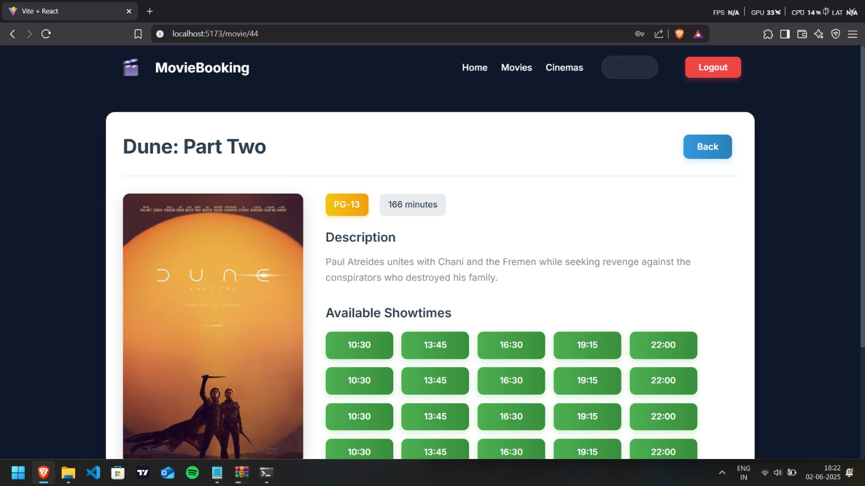

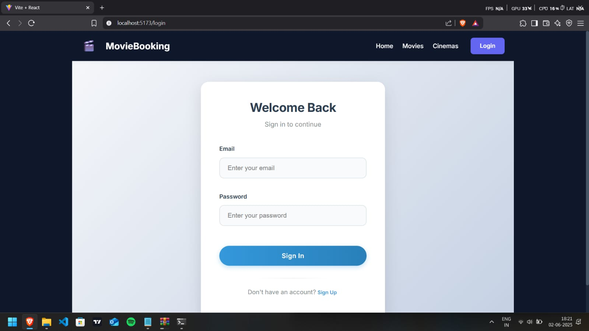

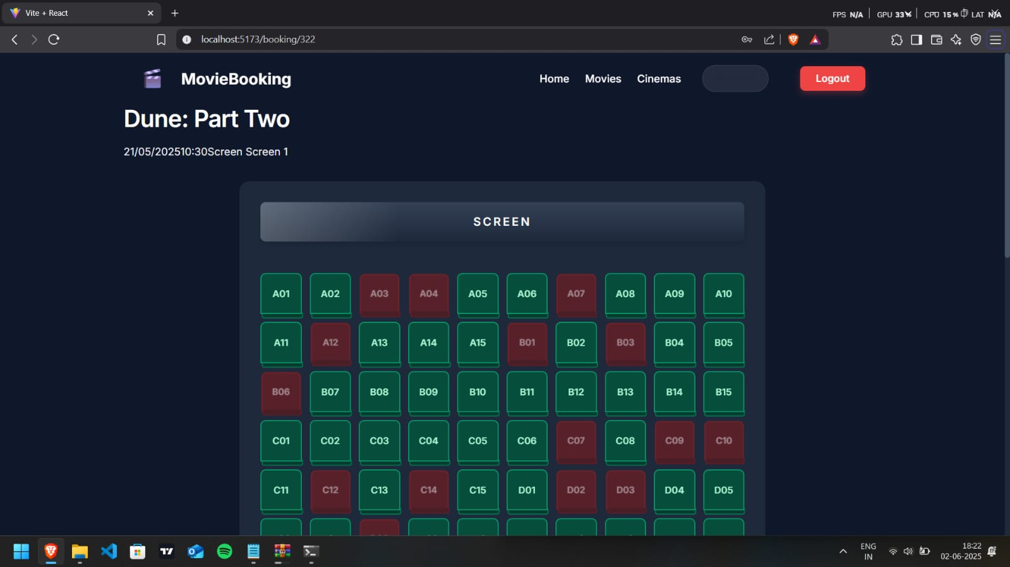

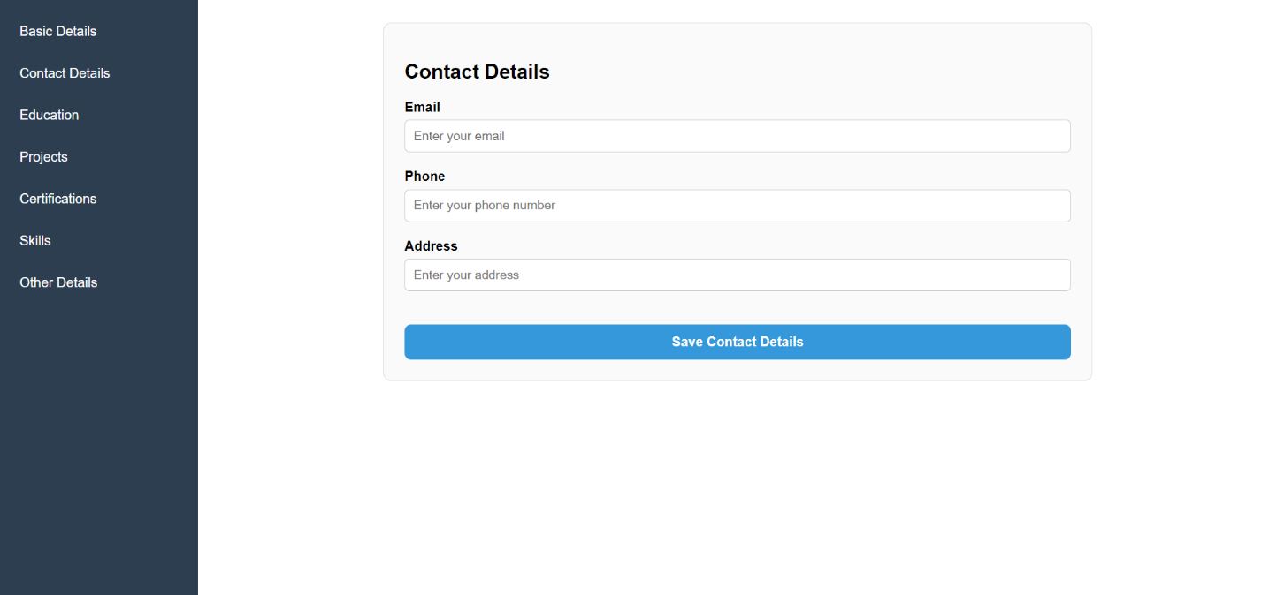

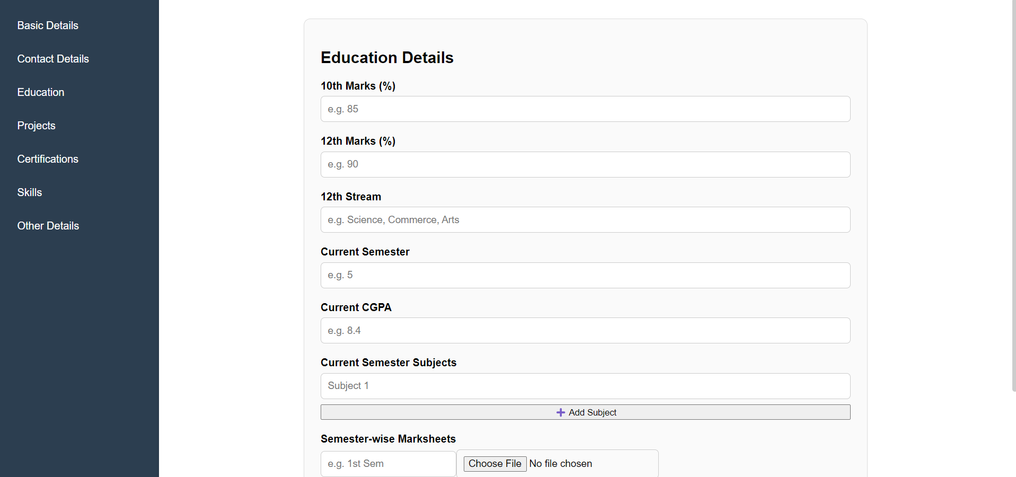

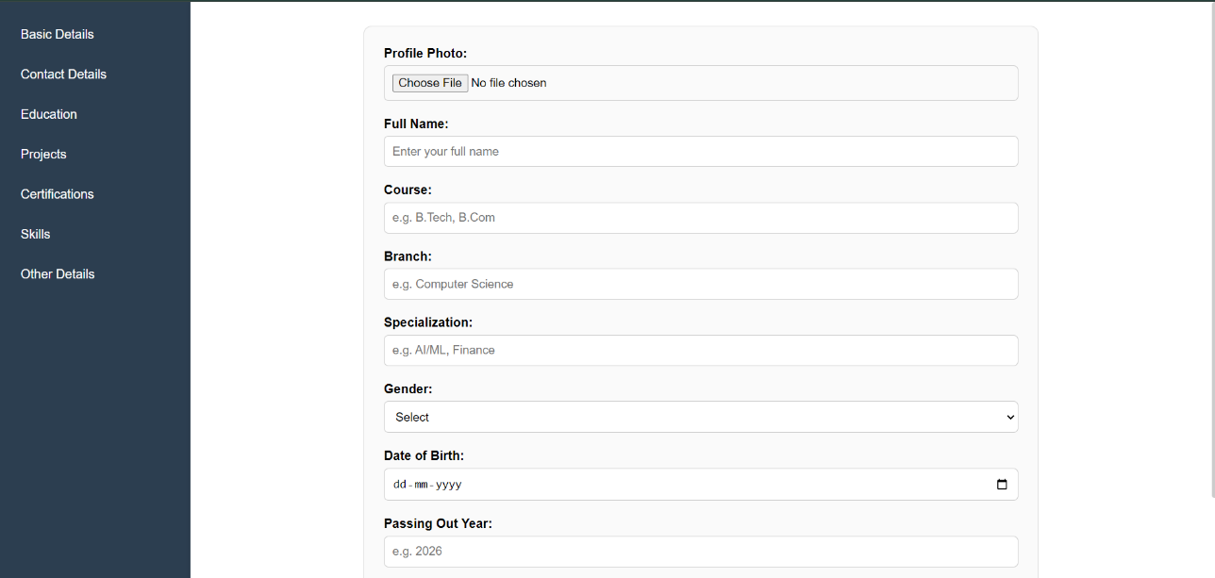



CHAPTER 5
TESTING

5.1 Introduction to Testing
Testing is a critical phase in the software development life cycle to ensure the accuracy, stability, and performance of the developed system. In the context of Academia, both functional and non-functional aspects were rigorously tested to verify that the platform meets its requirements for academic recommendation and real-time ticket booking under various usage conditions.

5.2 Testing Objectives
- Ensure system modules perform as intended.
- Verify integration between academic and entertainment components.
- Detect and fix bugs early before deployment.
- Test real-time concurrency in booking to avoid race conditions.
- Confirm security measures like authentication and data protection.
- Validate UI responsiveness and compatibility across devices.

5.3 Types of Testing Applied

1. Unit Testing
Each module (recommendation engine, authentication, booking logic) was tested in isolation using tools like Jest and Mocha.

2. Integration Testing
Interactions between components such as frontend-backend communication, database access, and API calls were tested to ensure seamless data flow using Postman and Insomnia.

3. Functional Testing
Verifies that core functionalities like:
- Login/Signup
- Course suggestions
- Movie seat selection
- Booking confirmation
all work as per requirements.

4. Load Testing
Used tools like Apache JMeter to simulate multiple concurrent users making seat bookings. Ensured no overbooking occurs due to optimized concurrency control.

5. Security Testing
JWT authentication was validated to ensure unauthorized users could not access restricted areas. Input validation was tested to prevent common attacks like XSS and SQL Injection.

6. UI/UX Testing
Frontend responsiveness, user flows, and design usability were tested manually and with automated tools across different browsers (Chrome, Firefox) and screen sizes (desktop, tablet, mobile).

5.4 Test Cases and Results
- Login Module: Entering incorrect credentials shows appropriate error.

- Course Recommendation: New user with no history receives content-based results. Returning user sees hybrid recommendations.

- Ticket Booking: Booking the same seat by two users simultaneously blocks the second request.

- Admin Controls: Verified that only authorized users can post new opportunities or manage movie listings.

- System Failover: Restarted backend services during activity—confirmed data consistency maintained.

5.5 Bug Tracking and Fixing
During testing, common bugs like improper form validations, broken links, and delayed API responses were logged using GitHub Issues and were iteratively resolved. Each bug fix was followed by a regression test to ensure it didn’t affect existing features.

5.6 Summary of Testing
The system was tested against a variety of input conditions and usage scenarios. All critical functionalities passed the tests, and the application is now stable and ready for deployment. Continuous testing will be carried out post-deployment for performance tuning and feature upgrades.

CHAPTER 6
RESULT AND DISCUSSION

6.1 System Functionality and Performance
The implemented system, Academia, was evaluated based on its intended functionalities and its real-time performance across both modules—Academic Recommendation and Movie Ticket Booking. The system successfully delivers a cohesive platform that serves the dual purpose of academic support and entertainment access for students, all within a unified user interface.
The Academic Module was tested for its ability to recommend relevant courses based on user interests and learning history. The hybrid recommendation engine, combining both content-based and collaborative filtering, produced meaningful suggestions, adapting over time as user interactions increased. Users could access tailored opportunities and educational content without manual searching, thereby improving engagement and decision-making in their academic journey. Notifications regarding new content, deadlines, and course relevance were delivered accurately, reflecting the system’s functional efficiency.
On the other hand, the Entertainment Module performed well under concurrency conditions. Users were able to view live seat availability and successfully book movie tickets in real-time. Concurrency control mechanisms effectively handled simultaneous booking attempts without seat duplication or overlap. Load testing further validated the booking system's robustness during peak hours, demonstrating that the backend was capable of handling multiple simultaneous requests while maintaining data integrity.
Overall, the system fulfilled its core objectives, and both modules interacted smoothly with the backend and database. The frontend remained responsive across devices, and the role-based access ensured secure navigation between user types such as admin, students, and viewers. From a performance standpoint, the application demonstrated low latency, consistent response times, and high accuracy in recommendations and bookings.
The results indicate that Academia not only meets its design goals but also offers a scalable and user-friendly solution to modern student needs, balancing academic progression and recreational relief within a single digital ecosystem.

6.2 Test Generation and Proctoring Integration in Academic Module
An important feature integrated into the Academic Module of Academia is the functionality for test generation and proctoring, which enhances the platform's educational value. The test generation system enables administrators or faculty to create dynamic question papers based on predefined templates or course topics. It supports both objective and subjective question types, and allows randomization of questions and options to ensure fairness and reduce cheating possibilities. The system also includes time-bound testing and automatic scoring for objective tests, thus simplifying assessment and feedback processes.
In parallel, the proctoring mechanism has been incorporated to maintain academic integrity during online examinations. A lightweight, AI-assisted proctoring feature monitors students using webcam access and activity tracking during the test. The system detects potential malpractices such as switching tabs, presence of multiple faces, or unusual movements. Suspicious activities are flagged and logged for post-exam review by the invigilator. This ensures that the testing environment is secure and credible, replicating real-world examination standards in a virtual space.
The integration of test and proctoring functionality within the academic module not only streamlines the evaluation process but also builds trust among students and faculty regarding the authenticity of assessments. Together, these features strengthen the academic module by introducing a structured, reliable, and secure testing environment that complements the recommendation and learning tools provided by the platform.

6.3 Performance Evaluation
The performance evaluation of the Academia system was conducted to ensure its stability, responsiveness, and efficiency under different user loads and functional scenarios. The system was tested across both modules—Academic and Entertainment—to analyze how well it handled operations like user authentication, course recommendations, test generation, and real-time seat booking for events. Load testing was performed using simulated users to evaluate the platform’s ability to handle concurrent access without significant delays or failures. The response times for database queries and API calls remained consistently within acceptable thresholds, indicating efficient backend performance.
In the entertainment module, special attention was given to concurrency control during ticket booking. Stress testing revealed that the system effectively prevented double bookings or race conditions, maintaining data integrity even during peak demand. Similarly, the academic module's recommendation system was evaluated for accuracy and relevance using sample user profiles. Results showed that the hybrid recommendation engine successfully delivered context-aware and personalized suggestions.
The system also maintained good scalability, with resource consumption optimized through modular coding and asynchronous operations. Furthermore, deployment in containerized environments using Docker and Kubernetes ensured smooth performance distribution and failover handling. Overall, the Academia platform demonstrated strong performance and reliability, meeting the expected standards for a scalable web application serving academic and recreational needs.

6.4 Discussion on Security and Reliability
Security and reliability are critical aspects of the Academia system, especially given the sensitive nature of academic data and the need for secure financial and seat reservation operations within the entertainment module. The system employs robust authentication mechanisms, including encrypted passwords and token-based user sessions, to protect against unauthorized access. Role-based access control (RBAC) further ensures that users can only interact with features appropriate to their permissions, preventing data leaks or privilege misuse.
To maintain data integrity and confidentiality, all user interactions with the backend are conducted over HTTPS, and sensitive operations—such as test generation, result submission, and ticket booking—are protected using input validation and backend-side verification. Additionally, the system logs abnormal behaviors and access attempts to support real-time monitoring and future auditing.
From a reliability perspective, the system has been designed using modular components with clear separation of concerns, reducing the risk of cascading failures. The use of containerization with Docker and orchestration via Kubernetes allows for high availability, load balancing, and auto-recovery, ensuring minimal downtime. Database transactions are handled with proper rollback mechanisms in case of errors, safeguarding against data corruption.
Overall, Academia demonstrates strong adherence to standard security practices while maintaining a reliable, consistent user experience, even under high load or unexpected conditions.

6.5 Limitations
Despite its comprehensive design, the Academia system has some limitations. First, the accuracy of the course recommendation module depends heavily on the quantity and quality of user data; limited data may reduce the personalization effectiveness. Second, the test generation and proctoring features, while integrated, rely on stable internet connectivity and compatible hardware, which may not be accessible to all users equally. Third, the real-time movie ticket booking module currently does not include payment gateway integration, limiting its ability to support complete transaction workflows. Additionally, the system lacks an administrative panel for managing dynamic content such as courses or movie listings, which could affect ease of updates. Finally, although basic security measures are implemented, advanced threat detection and multi-factor authentication are not yet incorporated, potentially exposing the system to sophisticated attacks.
CHAPTER 7
CONCLUSION AND FUTURE WORK

7.1 Conclusion
The Academia platform successfully bridges the gap between academic management and student entertainment by offering an integrated, user-centric web application. It addresses key challenges faced by students, such as accessing personalized educational content, managing tests with secure proctoring, and enjoying recreational activities like movie bookings—all within a single unified system. The use of modern technologies such as React for frontend, Node.js for backend, and databases like MongoDB and PostgreSQL has ensured a scalable, efficient, and responsive system architecture.
The intelligent recommendation engine, powered by machine learning, enhances user engagement by providing tailored academic and entertainment options, while concurrency control mechanisms safeguard system integrity during high-demand operations.
The proctoring module introduces an additional layer of academic integrity, reinforcing the platform’s credibility in education management. Overall, Academia exemplifies how combining multiple functionalities into a centralized system can greatly improve the student experience, streamline administrative processes, and open pathways for future innovation.

7.2 Future Work
While the current version of Academia demonstrates strong foundational capabilities, there remain several avenues for improvement and expansion to better serve students and administrators alike. Integration of secure, widely-used payment gateways such as Stripe, PayPal, or Razorpay would streamline the movie ticket purchasing workflow and enable monetization opportunities. The academic recommendation system could benefit from incorporating real-time data feeds from popular online learning platforms like Coursera, edX, and Udemy, making suggestions more current and relevant. To further improve recommendation quality, advanced AI techniques including deep learning models, reinforcement learning, and contextual natural language processing could be adopted.

For the test proctoring feature, future upgrades might include biometric authentication (such as facial recognition or fingerprint scanning), AI-driven behavior analytics to detect suspicious activities in real time, and live video monitoring to further minimize cheating. Developing a comprehensive, role-based administrative dashboard will empower educational institutions and entertainment providers with better control over content management, user analytics, and system settings.

Enhancing security is critical as the platform scales. Implementing multi-factor authentication (MFA), end-to-end encryption, and regular security audits can ensure user data privacy and protect against cyber threats. Moreover, mobile app versions for Android and iOS could increase accessibility and user convenience. Lastly, deploying the platform on cloud infrastructure with auto-scaling capabilities will ensure smooth performance during peak usage times.
By pursuing these improvements, Academia can evolve into a comprehensive, secure, and intelligent platform that not only meets but anticipates the dynamic needs of students in the digital age.

REFERENCES

    - Recognition. In Proceedings of the International Conference on Learning Representations (ICLR).

